**Assignment 17.1**

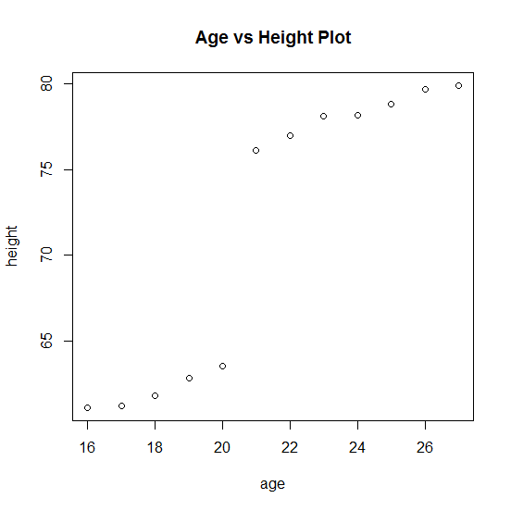

(4) Since the p value for height variable is less (2.28 e-05) and for intercept is high (0.111), we don't consider intercept. So the linear model equation will be : age = 0.38411 * height